Lab Assignment -3

1.

Question:

R Project

Prepare a dataset related to your own project and perform k-Means, K-Medians, Expectation Maximization (EM), and Hierarchical Clustering and report the results

Description:

Performed above methods on data set collected for the project. The Data set will contain list of symptoms and their resultant diseases.

Symptoms are hashed so that we can perform R operations on the data.

Screenshots:

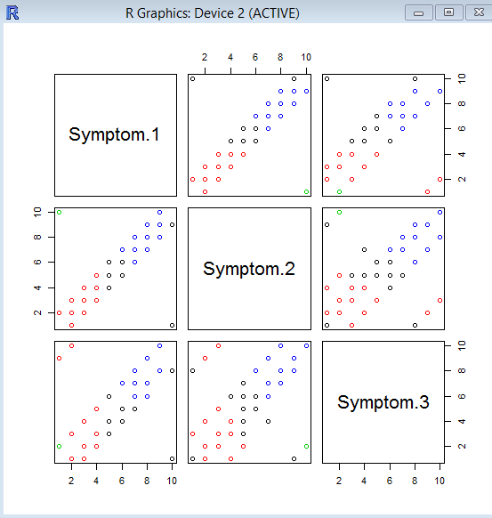

K Means

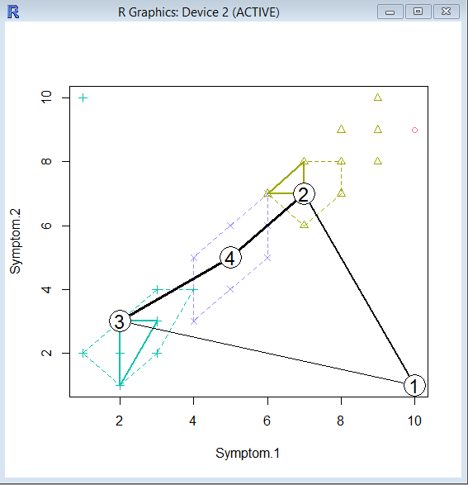

K Medians

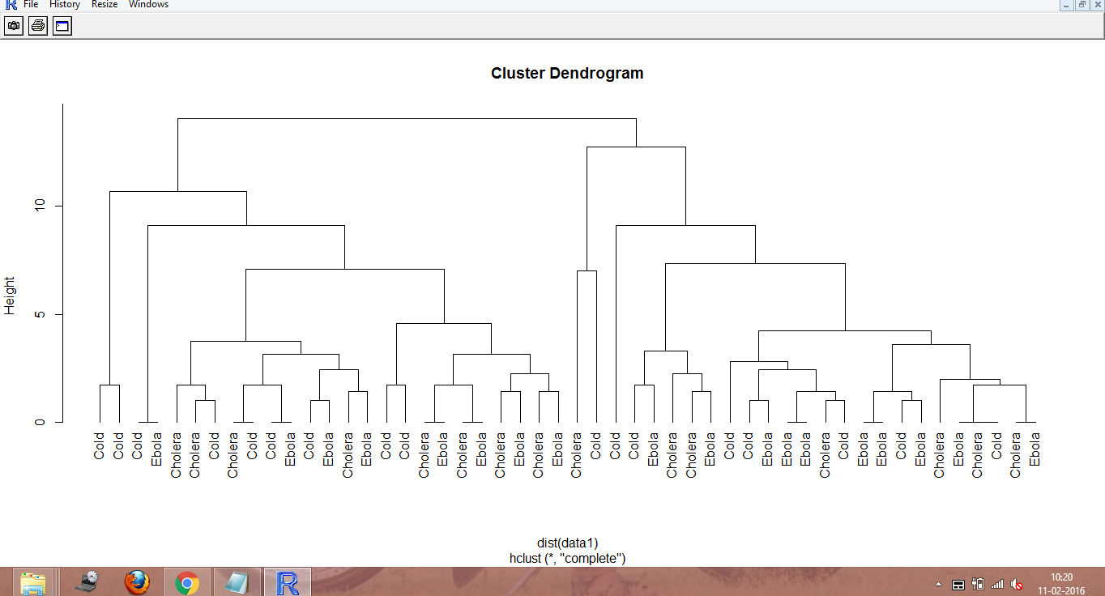

Hierarchical Clustering

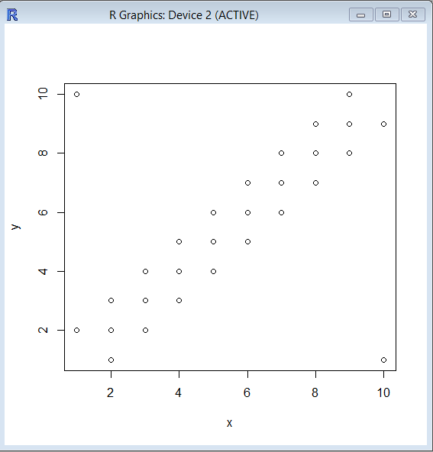

Expectation Maximization Graph

2.

Question:

RoboMe and Watch App

Data collection related to your own project through Smart Phone and Watch, send notifications to watch using intuitive data analysis.

Description:

Used in built location services to get the coordinates of the user.

We will be using these coordinates to pin point the location of user from which we will be calculating to distance to the destination.

Screen Shots:

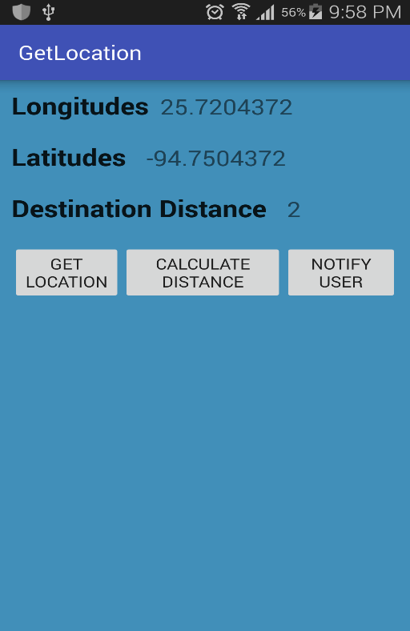

Main GUI

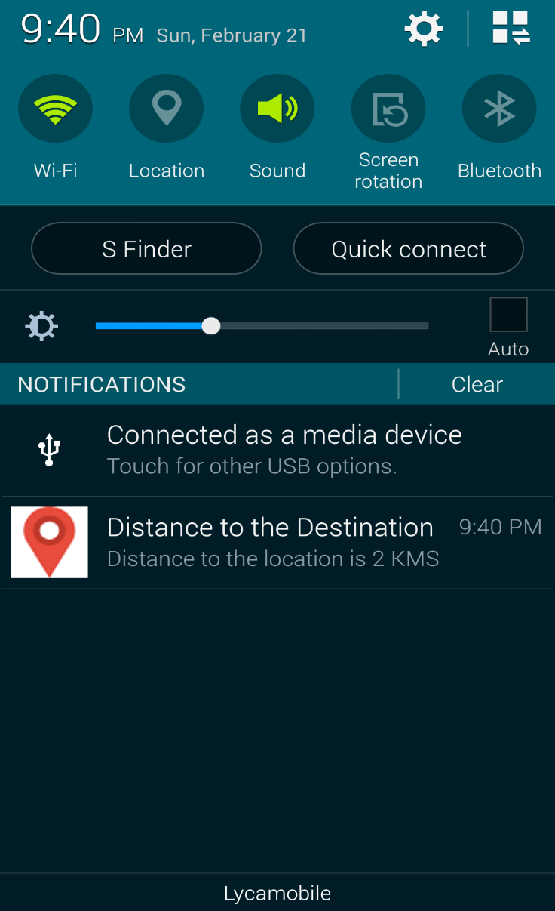

Notification to the user regarding distance to destination.